Abstract
Objectives: The GALS (Gait, Arms, Legs and Spine), examination is a compact version of standard procedures used by rheumatologists to determine musculo-skeletal disorders in patients. Computerization of such a clinical procedure is necessary to ensure an objective evaluation. This article presents the first steps in such an approach by outlining a procedure to use motion analysis techniques as a new method for GALS examination.

Method: A 3D motion pattern is obtained from two subject groups using a six camera motion analysis system. The range of motion associated with GALS test is consequently determined using a MATLAB program.

Results: The ROMs for the two subject groups are determined and the validity of the approach is outlined and the symmetry of movement on both sides of the body could is quantified through introduction of dependency coefficient.

Conclusion: Analysis of GALS examination and diagnosis of musculo-skeletal problems could be addressed more accurate and reliable by adopting motion analysis technique. Further, introduction of dependency coefficient offers a wide spectrum of prospective applications in neuro-muscular studies.

Key words: Motion analysis, GALS examination, Musculo-Skeletal disorders, Dependency Coefficient

1. Introduction
Visual evaluation of joints is an integral part of human motion assessment. Implementation of cinematography in biomechanical studies using motion capture technologies made a tangible contribution to further developments of human motion analysis systems. This particular combination of software and hardware has found diverse applications in such areas as military and computer vision. Motion analysis systems are also comfortably relied on by medical professionals in quantitative evaluation of musculoskeletal performance in rehabilitation, neurology and sports medicine. Individual disciplines, however, require tailor made software for a more coherent quantitative analysis. Examples of dedicated tools for disciplinary applications are neoumerous. A software for 3D analysis of musculoskeletal system is developed by Leardini et al [1]. The reliability and validity of standing balance measurements using motion analysis systems is discussed by Kejonen et al, [2]. Positioning verification of patient is also addressed utilizing real-time three dimensional motion analysis [3].
Einas [4] and his colleagues worked on pelvis skeletal asymmetry and its influence on trunk movement. The musculo-skeletal overuse injuries as a result of foot structure and range of motion are also studied [5]. Prediction of patellar tendon reflex is another disorder which is evaluated by 3D analysis of human movements [6]. The range of motion of human segments is a related parameter to musculo-skeletal system and Schmidt et al [7] addressed the issue by investigating unconstrained motion of wrist and elbow. Finger flexion and extension following a 3D video analysis is presented by Rash [8]. Other muscular parameters like belly length with a potential for the assessment of contracture is also investigated by Fry et al. [9].
The motion analysis systems are widely adopted as a diagnosing tool for investigation of musculoskeletal disorders. However, preliminary evaluation of patients is still subject to manual intervention by physiotherapists, rheumatologists and orthopedic surgeons. There are a number of slightly different routines for such an evaluation. The GALS examination (gait, arm, leg, and spine) has been validated as a new approach for screening musclo-skeletal disorders in primary care [10, 11, 12]. Here, the sensitivity, reliability and specificity, of this examination procedure have been investigated by physiotherapists in order to detect rheumatoid arthritis [13].
This paper represents a novel approach in adopting a dedicated motion analysis system for automatic evaluation of a patient musculoskeletal condition through substitution of the visual segment of GALS examination.
2. Materials and Methods
The visual evaluations constitute an integral and critical part of the GALS examination. During these clinical assessments, the physician is attempting to extract features associated with body segments at the same time that whole body configuration are kept in mind. Here factors such as ROM (range of motion), swelling, deformity, smoothness and symmetry of movements, tenderness and gripping ability are assessed. The visual evaluation however, concentrates primarily upon assessment of range of motion for individual joints. In the following sections a protocol for parameter estimation during these examinations is developed. A number of issues that defines the existing tests such as GALS should also be taken into considerations. In the first instant, the objectives of the original test should be adhered to and both sides of the body should be assessed [13]. Furthermore, no additional or external forces should be applied to the subject’s body during evaluation of the active range of motion. Table 1, is presenting the basic structure of this protocol.
The positioning of the passive or active markers plays an important role in this screening protocol. Here the Helen-Hayse marker-set [15] is adopted for location of the markers. The other practical issue is what the patient should wear during screen. On skin marker placement require the male subjects to wear stretch shorts. The female subjects could additionally wear a simple but specially prepared top which is similar to a kitchen apron with open back.
The motion analysis system adopted for this study is a six infrared cameras Vicon system with and Vicon data station &workstation software. The motion was captured at 60 fps as the speed is highly suitable for this type of movement. The results are in the form of Microsoft Excel Format. An M-File code is then prepared for Matlab R2007b. The code is responsible to accept the motion analysis software output and provides the corresponding stick figures and the associated joint ROM.
For practical implementation of the protocol eight undergraduate Biomedical Engineering students at Amirkabir University of Technology, forming the two study groups provided assistance. Table 2, illustrates the demographic profile of the two subject groups.

Table 1. Represents the structure of the developed protocol for the Automatic GALS screening
Subcategory | Movement | Description | Assessment Method
Gait
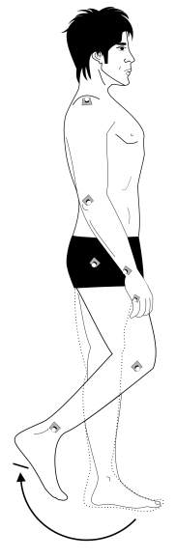 | Walking at comfortable pace | 3D Gait Analysis | Evaluation of walking pattern by tracking Ankle landmark
Arm
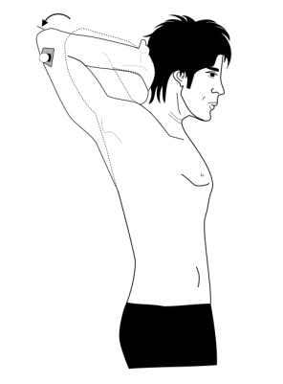 | Shoulder external rotation | Dressing ability: Elbow-shoulder is pulled back from coronal plane | The angle of rotation of the arm
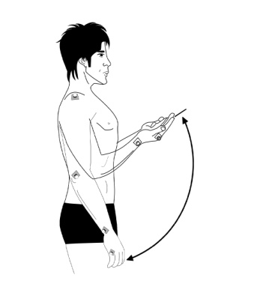 | Arm flexion | Standing upright with arms hanging, the arm is then rotated upwards | The angle of rotation of the arm
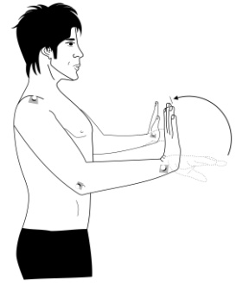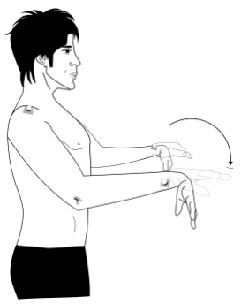 | Wrist flexion & extension | Arms hanging freely, hands are kept horizontally at right angles to arms, Wrist is rotated upwards and down wards | Wrist rotation
Leg
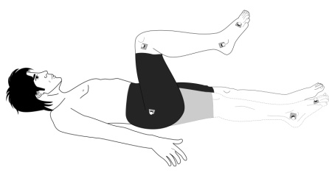 | Knee flexion | Lying on the couch, foreleg is free while thigh is brought up | The angle of knee flexion
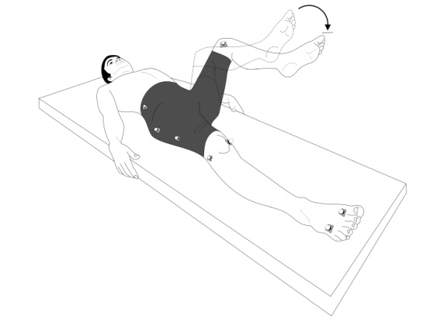 | Hip internal rotation | Passive Internal Rotation of individual hips | Lateral rotation of foreleg
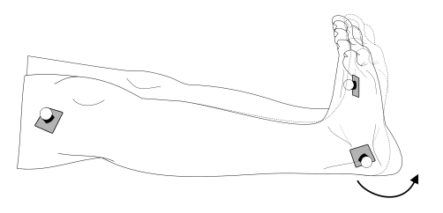  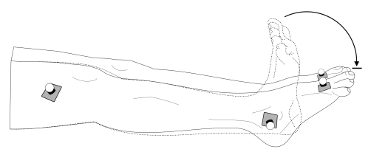 | Ankle Dorsi& Plantar Flexion | Rotating foot from vertical moving back and forth | Foot-foreleg angle
Spine
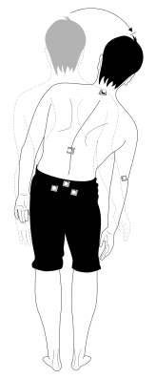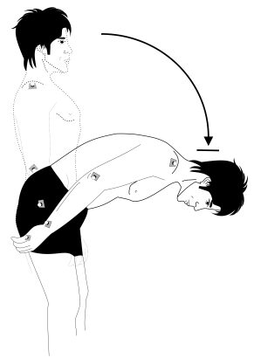 | Waist Lateral Bending  Waist Flexion | Keeping waist stationary, bending the upper extremity laterally  T10-S1 bending forward | Angle of motion of the T10-S1 line  T10-S1 forward angle

Table 2. Descriptive profiles of two study groups
Variable | Male | Female
Age (Yr) | 20.25±0.5 | 19.25±0.5
Weight (Kg) | 69.50±10.345 | 59.25±1.259
Height (Cm) | 173.25±7.676 | 160.25±6.397
BMI (Kg/m²) | 23.05452±1.894 | 23.14453±1.736

3. Results

The ROMs for the two subject groups is determined and tables 3 & 4 represent the subject data summary for male and female participants. Total average and standard deviations are calculated for individual rows in tables 3&4.Here the average of female and male participants is determined separately for individual movements. The segmental range of motion found in references is also presented at the last column of each row. Fig.1 represents the right and left lateral bending against one

another. The left and right shoulder extensions are also illustrated in Fig2. Fig.3, presents the forearm flexion data in both of left and right side. Fig.4&5, show wrist flexion and extension from both left and right sides. Furthermore, knee flexions data in both sides are shown in Fig 6.
Hip internal rotation is also presented in both left and right sides are shown in Fig. 7. The ankle has two separate sets of data in plantar flexion and dorsi flexion as they have illustrated in Fig. 8 and Fig. 9.

Table 3. GALS examination's results for male measured with motion analysis system. All data are in degree scale.
 | Case 1 | Case 2 | Case 3 | Case 4 | Average | STD | Normal
Right Lateral Bending | 24.0246 | 29.7182 | 35.2918 | 40.0987 | 32.2833 | 6.950 | 0-25
Left Lateral Bending | 23.9208 | 33.4874 | 31.5047 | 35.292 | 31.0513 | 4.999 | 0-25
Waist Flexion | 60.5308 | 104.3238 | 109.8251 | 125.152 | 99.9579 | 27.72 | 0-90
Right Shoulder External Rotation | 17.3221 | 31.926 | 24.4186 | 41.997 | 28.9159 | 10.56 | 0-45
Left Shoulder External Rotation | 15.1735 | 34.5632 | 28.3996 | 44.212 | 30.5872 | 12.16 | 0-45
Right Elbow Flexion | 86.2745 | 69.9636 | 93.0814 | 75.689 | 81.25225 | 10.384 | 0-150
Left Elbow Flexion | 84.3018 | 72.9452 | 90.3523 | 66.247 | 78.46165 | 10.879 | 0-150
Right Wrist Flexion | 92.0787 | 57.4011 | 83.1725 | 75.600 | 77.0632 | 14.736 | 0-60
Left Wrist Flexion | 88.3375 | 46.6831 | - | 69.836 | 68.2858 | 20.870 | 0-60
Right Wrist Extension | 42.7776 | 56.7274 | 46.5528 | 51.401 | 49.3649 | 6.045 | 0-60
Left Wrist Extension | 28.0795 | 51.2704 | 51.2363 | 45.084 | 43.9177 | 10.951 | 0-60
Right Knee Flexion | 116.5022 | 126.0008 | 110.4196 | 127.351 | 120.0684 | 8.042 | 0-150
Left Knee Flexion | 120.3755 | 126.675 | 130.9287 | 127.891 | 126.4677 | 4.437 | 0-150
Right Hip Internal Rotation | 13.1893 | 30.7545 | 29.5033 | 33.355 | 26.70065 | 9.149 | 0-45
Left Hip Internal Rotation | 14.734 | 33.5029 | 34.6577 | 38.629 | 30.381 | 10.659 | 0-45
Right Ankle Dorsi Flexion | 8.3628 | 41.5896 | 22.5732 | 27.309 | 24.9587 | 13.701 | 0-20
Left Ankle Dorsi Flexion | 7.9059 | 47.0624 | 24.0755 | 30.878 | 27.4804 | 16.225 | 0-20
Right Ankle Plantar Flexion | 7.3029 | 12.9306 | 17.4082 | 29.824 | 16.8665 | 9.577 | 0-50
Left Ankle Plantar Flexion | 8.1441 | 16.4978 | 23.6389 | 34.735 | 20.75415 | 11.268 | 0-50
Left Knee in Gate Process | 75.23 | 63.9687 | 85.781 | 111.7 | 84.1699 | 20.400 | 0-120
Left Hip in Gate Process | 51.52 | 45.1286 | 62.2004 | 63.79 | 55.6597 | 8.886 | 0-80

Table 4. GALS examination's results for female measured with motion analysis system. All data are in degree scale.
 | Case 5 | Case 6 | Case 7 | Case 8 | Average | STD | Normal
Right Lateral Bending | 35.3272 | 27.0138 | 41.8696 | 30.0579 | 33.567 | 6.513 | 0-25
Left Lateral Bending | 33.7315 | 27.3634 | 40.5171 | 31.6614 | 33.319 | 5.483 | 0-25
Waist Flexion | 81.4195 | 73.2734 | 78.9933 | 63.1135 | 74.20 | 8.141 | 0-90
Right Shoulder External Rotation | 29.9495 | 42.9042 | 52.0556 | 43.6244 | 42.135 | 9.123 | 0-45
Left Shoulder External Rotation | 40.2838 | 34.6775 | 53.0795 | 49.1322 | 44.29 | 8.349 | 0-45
Right Elbow Flexion | 73.062 | 88.854 | 98.3156 | 103.1699 | 90.850 | 13.265 | 0-150
Left Elbow Flexion | 65.4103 | 74.5736 | 99.2266 | 89.4009 | 82.152 | 15.075 | 0-150
Right Wrist Flexion | 56.7717 | 52.5711 | 61.2721 | 78.1051 | 62.18 | 11.195 | 0-60
Left Wrist Flexion | 69.6553 | 68.8519 | 58.7572 | 86.1088 | 70.843 | 11.320 | 0-60
Right Wrist Extension | 18.7698 | 58.7179 | 53.5452 | 46.5443 | 39.62 | 18.392 | 0-60
Left Wrist Extension | 15.6217 | 53.1221 | 60.8213 | 59.4073 | 47.243 | 21.344 | 0-60
Right Knee Flexion | 127.2142 | 126.1644 | 125.0407 | 117.1573 | 123.895 | 4.578 | 0-150
Left Knee Flexion | 123.4088 | 126.6062 | 127.6217 | 114.5348 | 123.043 | 5.949 | 0-150
Right Hip Internal Rotation | 44.6373 | 38.5630 | 35.2774 | 32.0348 | 37.316 | 6.544 | 0-45
Left Hip Internal Rotation | 46.8059 | 36.304 | 42.3485 | 30.703 | 39.040 | 7.029 | 0-45
Right Ankle Dorsi Flexion | - | - | 39.1348 | 29.6971 | 34.415 | 6.673 | 0-20
Left Ankle Dorsi Flexion | 27.9981 | 14.4352 | 46.0564 | 27.0056 | 33.686 | 10.723 | 0-20
Right Ankle Plantar Flexion | 7.3029 | - | 11.4411 | 18.7717 | 15.106 | 5.183 | 0-50
Left Ankle Plantar Flexion | 24.2201 | 20.4623 | 36.9028 | 16.6293 | 25.917 | 10.242 | 0-50
Left Knee in Gate Process | 113.6394 | 127.741 | 133.7182 | 61.98 | 109.269 | 32.630 | 0-120
Left Hip in Gate Process | 69.8592 | 91.1451 | 78.2261 | 43.7 | 70.732 | 20.036 | 0-80

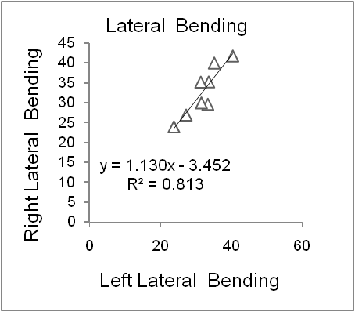
(Deg)
(Deg)
Fig. 1. Right lateral bending against left lateral bending
(Deg)
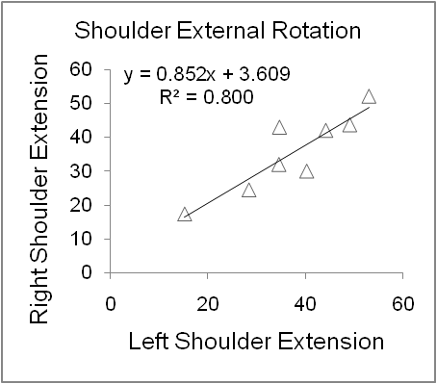
(Deg)
Fig. 2. Right shoulder external rotation against left shoulder external rotation
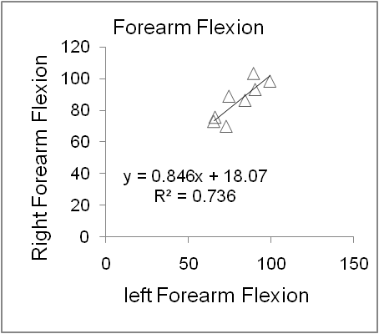
(Deg)
(Deg)
Fig. 3. Right forearm flexion against left forearm flexion
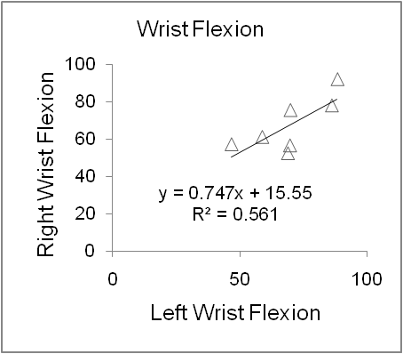
(Deg)
(Deg)
Fig. 4. Right wrist flexion against left wrist flexion

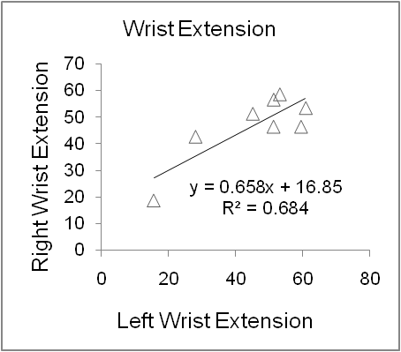
(Deg)
(Deg)
Fig. 5. Right wrist extension against left wrist extension
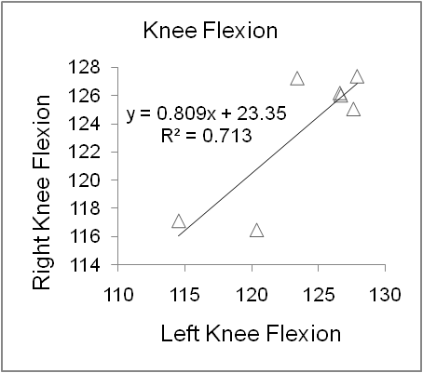
(Deg)
(Deg)
Fig. 6. Right knee flexion against left knee flexion
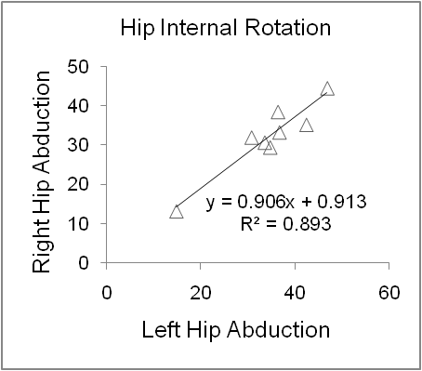
(Deg)
(Deg)
Fig. 7. Right hip internal rotation against left hip internal rotation
(Deg)
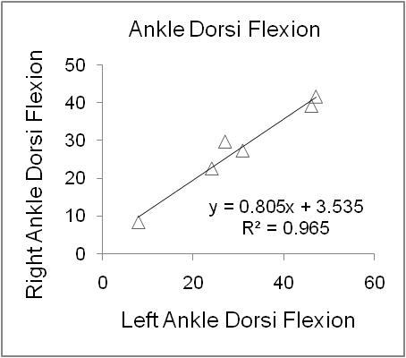
(Deg)
Fig. 8. Right ankle dorsi flexion against left ankle dorsi flexion

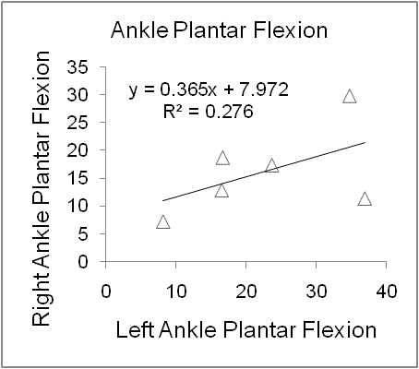
(Deg)
(Deg)
Fig. 9. Right ankle plantar flexion against left ankle plantar flexion
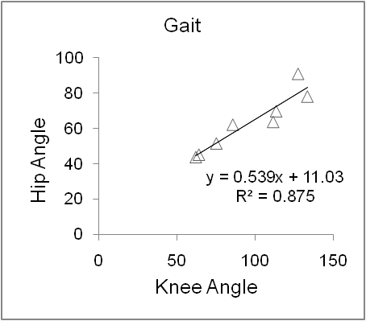
(Deg)
(Deg)
Fig. 10. Left knee angle against left hip angle in gait analysis
4. Discussion

In this paper a procedure based on motion analysis is presented as a new or an alternative means by which an important part of the GALS screening procedure could be performed. The current clinical procedure results in a predominantly experience based and subjective grading arrived at by the physician. An automatic evaluation, however, could provide a far more reliable and repeatable results through objective screening. Here objectivity is obtained through motion analysis followed by an automatic comparison of the results against an accepted set of criteria [16], thus introducing a decision making platform using Matlab 2007 Rb, to assist the physician a step further. The potential for addition of different algorithms to the automatic comparison stage is yet another benefit of this approach. For example the symmetry of movement on both sides of the body could be quantified using a dependency coefficient (R), which is a measure of asymmetry on individual body planes. This is exemplified by dependency coefficient (R), of waist lateral bending on both sides on frontal plane, as shown in Fig. 10. This coefficient has values between 0 & 1, and the higher this value, the higher would be the symmetry. Higher values of R, on the other hand, are not necessarily associated with ROM.
To exemplify the point, the spine and gait tests are taken to a diagnostic stage to see how dependency coefficient arrived at by automatic motion analysis, becomes meaningful in clinical terms. In the case of subject7, higher normal flexibility is encountered during waist lateral bending while the movement is quite symmetrical. Alternatively, in the case of subject 4, the results of automatic assessment of GALS procedure is indicative of a lack of symmetry at the same time that higher than normal flexibility is observed. Lack of symmetry can be associated with shortening of quadratus lumborum. Alternatively, S shape scoliosis in both thoracic and lumbar areas could lead to limitations which are here manifested by smaller than expected dependency coefficient. The torsion and shearing in pelvis, caused by sacro-iliac dysfunction, could also be considered as yet another reason for limitations on lateral bending.
In gate analysis two parameters are considered. These are knee angle and hip angle on sagital plane for one complete cycle. A single side view analysis could be justified by the assumption that existence of any pathological states on one side directly affects both knee and hip angles on the other side. Cases 1, 2 and 3 in tables 3 and 4, could be considered as indications of center of mass swing deviation during the gate cycle which in turn, is an indication of knee compensation in response to weaknesses exhibited by the combination of hip and pelvis. Finally, there is a reasonable dependency between knee and hip angles in Fig. 10 that proves all above explanations [17].
Understanding affected function by pathology and impairment may be critical in diagnosis, also designing effective treatments for preventing and curing disability due to musculoskeletal diseases.
As described by Winter, joint mechanical power and energy terms reflect the underlying neuromuscular control mechanisms of human movement, and thus are potentially useful for quantifying neuromuscular adaptations and compensations for impairment [18].
Compensation may be defined, in physiologic terms, as a substitution process whereby the function of healthy body systems fulfill the role(s) of diseased or defective body systems. The neuromuscular system is significantly redundant, offering numerous possible solutions for generating the required extremity kinematics [19].
This flexibility in neuromuscular patterning potentially allows one to ambulate effectively with impairments. Several studies suggest that the hip is used to compensate for weakness in knee extensor and/or ankle plantar flexor muscles of otherwise healthy [20].
Gait compensations for hip muscle weakness can produce independent (i.e. successful) ambulation, although at a reduced speed as compared to normal gait [21].
5. Concluding Remarks
Motion analysis provides the instrumentation necessary for an objective evaluation of GALS examination and diagnosis of musculo-skeletal problems. Accuracy of medical diagnosis can be effectively altered by adopting a reliable and repeatable procedure using motion analysis techniques. Introduction of the concept of dependency coefficient could open the way towards further neuro-muscular investigations and the lack of symmetry could lead to personalized conditioning programs tailored for both healthy weaknesses and pathological states. Although implementation of such a technology might at first, seem time consuming, expensive, and requiring specialized technician support for medical professionals, further development of this approach will undoubtedly prove the system to be an invaluable asset. This is particularly tangible when a large group of people like the numbers encountered in health screenings for company staff is intended.
Acknowledgement
This research has been supported by a grant from the University of Social Welfare and Rehabilitation Science, department of Ergonomist, Biomechanics laboratory, Tehran, Iran.
References
[1] A. Leardini C. Belvedere L. Astolfi, S. Fantozzi M. Viceconti F. Taddei A. Ensini M.G. Benedetti F. Catani, A new software tool for 3D motion analyses of the musculo-skeletal system, Clinical Biomechanics 21 (2006) 870–879

[2] Kejonen P, Kauranen K, Reliability and validity of standing balance measurements with a motion analysis system, Physiotherapy, 88, 1, (2001)25-32

[3] Guido Baroni, Giancarlo Ferrigno, Roberto Orecchia, Antonio Pedotti, Real-time three-dimensional motion analysis for patient positioning verification, Radiotherapy and Oncology 54 (2000) 21-27
[4] Einas Al-Eisa, David Egan, Kevin Deluzio, and Richard Wassersug, Effects of Pelvic Skeletal Asymmetry on Trunk Movement, SPINE Volume 31, Number 3, pp E71–E79(2006)
[5] Kenton R. Kaufman, Stephanie K. Brodine, Richard A. Shaffer, Chrisanna W. Johnson, Thomas R. Cullison, The Effect of Foot Structure and Range of Motion on Musculoskeletal Overuse Injuries, Am J Sports Med September 1999 vol. 27 no. 5 585-593
[6] L.K. Tham, N.A. Abu Osman, K.S. Lim, B. Pingguan-Murphy, W.A.B. Wan Abas, N. MohdZain, Investigation to predict patellar tendon reflex using motion analysis technique, Medical Engineering & Physics 33 (2011) 407–410

[7] Joanne O. Crawford, ElpinikiLaiou, Anne Spurgeon, Grant McMillan, Musculoskeletal disorders within the telecommunications sector—A systematic review, International Journal of Industrial Ergonomics 38 (2008) 56–72

[8] Ralf Schmidt, Catherine Disselhorst-Klug, Jiri Silny, Gunter Rau, marker-based measurement procedure for unconstrained wrist and elbow motions, Journal of Biomechanics 32 (1999) 615}621

[9] Gregory S. Rash, P.P. Belliappa, Mark P. Wachowiak, Naveen N. Somia, Amit Gupta, A demonstration of the validity of a 3-D video motion analysis method for measuring finger flexion and extension, Journal of Biomechanics 32 (1999) 1337-1341

[10] N.R. Fry, C.R. Childs, L.C. Eve, M. Gough, R.O. Robinson, A.P. Shortland, Accurate measurement of muscle belly length in the motion analysis laboratory: potential for the assessment of contracture, Gait and Posture 17 (2003) 119_/124

[11] Michael Doherty, Jane Dacre, Paul Dieppe, Michael Snaith, The 'GALS' locomotor screen, Annals of the Rheumatic Diseases 1992; 51: 1165-1169

[12] MJ Plant, S Linton, E Dodd, P WJones, P T Dawes, The GALS locomotor screen and disability, Annals of the Rheumatic Diseases 1993; 52: 886-890

[13] Karen A Beattie, Raja Bobba, ImaanBayoumi, David Chan, IngeSchabort, Pauline Boulos, Walter Kean, Joyce Obeid, Ruth McCallum, George Ioannidis, Alexandra Papaioannou and Alfred Cividino, Validation of the GALS musculoskeletal screening exam for use in primary care: a pilot study, BMC Musculoskeletal Disorders 2008, 9:115

[14] Karen A.Beattie, NormaJ.MacIntyre, JessicaPierobon, JenniferCoombs, Diana Horobetz, AlexisPetric, MaraPimm, WalterKean, MaggieJ.Larché, Alfred Cividino, The sensitivity, specificity and reliability of the GALS (gait, arms, legs and spine) examination when used by physiotherapists and physiotherapy students to detect rheumatoid arthritis, Physiotherapy (2011), doi:10.1016/j.physio.2010.11.008

[15] Tabakin D., Vaughan CL., A comparison of 3D gait models based on the Helen Hayes marker set, In: Proceedings of the sixth international symposium on the 3D analysis of human movement,2000, p, 98-101.
[16]Soucie JM, Wang C, Forsyth A, Funk S, Denney M, Roach KE, Boone D, and the Hemophilia Treatment Center Network. Range of motion measurements: reference values and a database for comparison studies. Haemophilia 2010; e-pub November 11, 2010.
[17] Rodrigo S., García I., Franco M., Alonso-Vázquez A., Ambrósio, J., Energy expenditure during human gait. II - Role of muscle groups, Engineering in Medicine and Biology Society (EMBC), Aug. 31 2010-Sept. 4 2010 , 4858 - 4861
[18] Winter DA., Biomechanics and motor control of human movement, 2nd ed. New York: John Wiley and Sons; 1990.
[19] Zajac FE., Understanding muscle coordination of the human leg with dynamical simulations. Journal of Biomechanics 2002;35:1011–8.
[20] Judge JO., Davis RB III, Ounpuu S., Step length reductions in advanced age: the role of ankle and hip kinetics, J Gerontol A BiolSci Med Sci 1996;51:M303–12.
[21] Karen Lohmann Siegel, Thomas M. Kepple and Steven J. Stanhope, A case study of gait compensations for hip muscle weakness in idiopathic inflammatory myopathy, Clinical Biomechanics, Volume 22, Issue 3 , Pages 319-326, March 2007

