Apert syndrome: a case report
Nazila AkbarFahimi; PhD student of Occupational Therapy, Occupational Therapy Department, University of Social Welfare and Rehabilitation Science,Tehran,Iran.
Tel: 021-22180037 e-mail:fahimi1970@yahoo.com
Masoud Gharib:MSc of Occupational Therapy, Pediatric Neurorehabilitation Research center . University of Social Welfare and Rehabilitation Science,Tehran,Iran.
Tel: 021-22180099 e-mail: gharib_masoud@yahoo.com

Abstract:
Apert syndrome is a genetic defect which was first described by Eugene Apert in 1906. it's incidence is approximately one in 50000 births. This syndrome is many abnormalities in your body and Central Nervous System. rehabilitation can increase children and their parent's quality of life.We report a case of Apert syndrome and his occupational therapy program.
Key Words: Apert syndrome,Rehabilitation

Introduction:
Over the past decades advances have been made in the prevention and treatment of developmental malformations. This revolution in our conceptualization of developmental anomalies, has led to an improved ability to handle and prevent them. Despite these improvements, some conditions remain or continue to exhibit a large number of sporadic occurrences(1).
Apert syndrome is one of these conditions. It is a genetic defect which was first described by Eugene Apert in 1906. Apert syndrome is known to be inherited in an autosomal dominant with complex multisystem disorder, but most cases are sporadic. Although Apert syndrome is rare ,it's incidence is approximately one in 50000 births.(4.5 percent of all craniosynostosis show Apert syndrome)(1, 2).
This syndrome is characterized by: craniofacial dysmorphy, hands and feet syndactyly and craniosynostosis (premature fusion of cranial sutures).other anomalies are including: congenital heart defects, Central Nervous System (CNS) abnormalities (including defect of corpus callosum and ventriculomegaly), limitation of shoulder movement, short humerus,urogenital anomalies, dermatologic manifestations, hearing loss, ear infection, sleep apnea, severe acne, poor intellectual development, and increased incidence of eye injuries. (3, 4).
Apert syndrome has no known cure but orthopedic surgery can help correct the abnormalities, surgery occure in three steps: release of fusion, midfaced advancement and correction of wide set eyes.other surgeries may be necessary depending on their individually problems (such as: myringotomy, tracheotomy).Also rehabilitation can increase children and their parent's quality of life(5).We report a case of Apert syndrome and his occupational therapy program. He was diagnosed by neurologist and physical examination.
Case report:
"B.H" is a 3.11 years old boy. He has many aspects of Apert syndrome but no cardiac disorder. This young man has been referred to Occupational therapy due to psychomotor retardation by age 15months.He is the first child of nonrelatives' young parents with history of epilepsy in the maternal aunts.
Pregnancy: Sever edema with hypertension since 5thmonth and amniotic leakage from6th month.
Delivery: cesarean section(C/S) by 32 weeks due to rupture of membranes and hemorrhage. Birth weight was 2200 gm. He was admitted due to poor feeding and severe irritability by 7thday.
Immunization: Update, he had 3 days high fever after first time immunization.
EEG: abnormal (slow background with scattered slow spike waves.
MRI: prominence of brain sulci and ventricular system is noted for his age indicative of brain atrophy .Corpous calosum is hypo plastic especially in spelenium part.
Abdominal ultrasound: NL
TORCH: NL
ABR: Bilateral sensorial neural deafness
Ophthalmologic consultation: bilateral cataract (had been operated by age 2 months)
Chromosomal study: NL (Fig1)
Metabolic study including serum and urinary A.A serum NH3, lactate, Urinary reducing substances was NL.
Medication: Primidon 20 mg/kg/day
Growth &Development at first OT observation (by age 15 month): Head control on porn position, no sitting, no speech, no hand regard or using. He has irritable, hyper sensitivity, mild hip abduction restriction, large hand thumb, polydactylia of hand (Fig2)and foot double and fused foot thumb. He has no good eye contact and no organomegaly or skin disorder and no good swallowing.
He had surgical operation for polydactylia by 19months.
Fig1: Twenty metaphase spreads were studied on the basis of GTG technique at 500 band resolution, revealing 46 chromosomes .No chromosomal aberration detected.

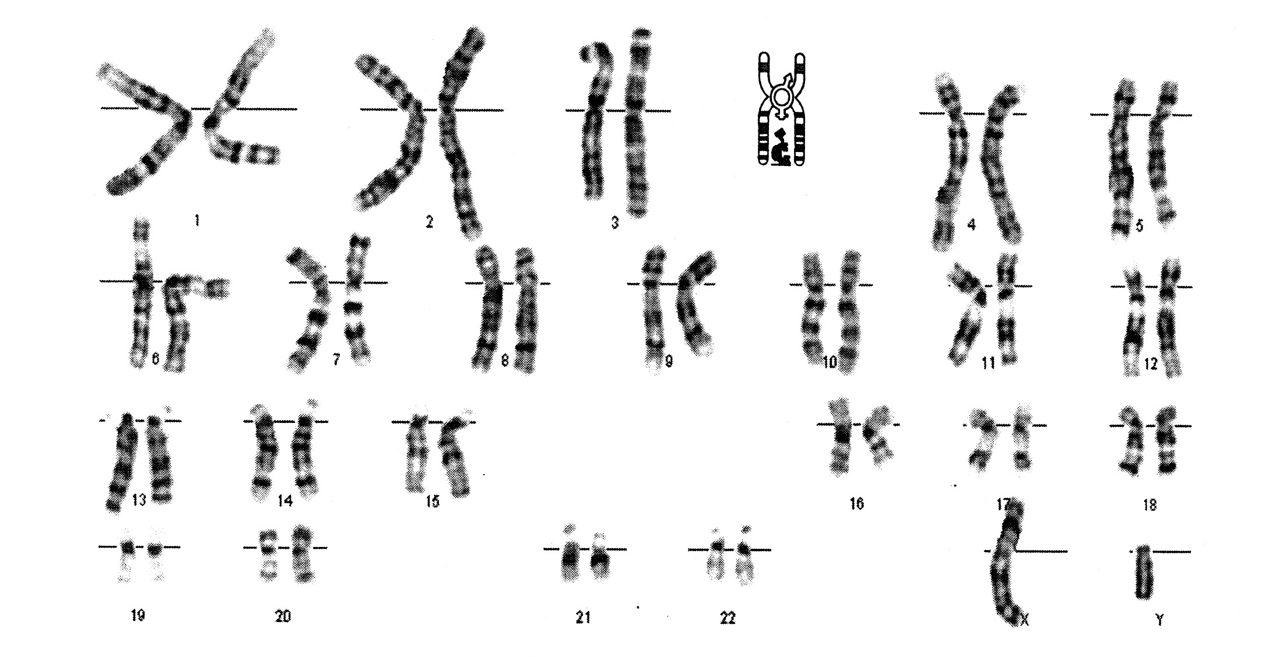

Fig2: polydactylia of hand

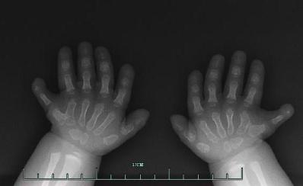

Occupational therapy interventions:
OT programs for B.H was based on Neurodevelopment facilitation techniques ,feeding program and dark room . After 12 months OT intervention-47 sessions ,he is more cooperative, more alert and fair swallowing .He has no tremendous motor system improvement ,only he can control his head, sits with support ,rolls off to two sided and reacts to others.
OT programs for his parents were included: 1)Activity Daily Living(ADL) training such as bathing, bed mobility, dressing and eating.2)Injury prevention or reduction education and safety awareness training during his care with use caring methods and suitable devices.3)emotional and social support to coping with this condition and 4) train coping strategies.
After 12 months OT program his parents have learned caring methods very well and their level of quality of life improved significantly (according to SF-36 questionnaire).
Conclusion:
Apert syndrome is rare and no known cure, parents with these children may lack knowledge and skill in specific areas of parenting, such as mobility, providing for a child's safety, feeding, or daily routine care. Rehabilitation team especially Occupational Therapists can provide these services. They can help parents to coping their condition and to participate fully in their role of parents.
Keywords: Apert syndrome, Occupational therapy, case report
Refrances:
1. Tolarova MM, Harris JA, Ordway DE, Vargervik K. Birth prevalence, mutation rate, sex ratio, parents' age, and ethnicity in Apert syndrome. American Journal of Medical Genetics. 1997;72(4):394-8.
2. Freiman A, Tessler O, Barankin B. Apert syndrome. International Journal of Dermatology. 2006;45(11):1341-3.
3. Cohen MM, Kreiborg S. The central nervous system in the Apert syndrome. American Journal of Medical Genetics. 1990;35(1):36-45.
4. Faro C, Chaoui R, Wegrzyn P, Levaillant JM, Benoit B, Nicolaides KH. Metopic suture in fetuses with Apert syndrome at 22–27 weeks of gestation. Ultrasound in Obstetrics and Gynecology. 2006;27(1):28-33.
5. Glaser RL, Broman KW, Schulman RL, Eskenazi B, Wyrobek AJ, Jabs EW. The Paternal-Age Effect in Apert Syndrome Is Due, in Part, to the Increased Frequency of Mutations in Sperm. The American Journal of Human Genetics. 2003;73(4):939-47.

