ATTENTIONAL DEMANDS OF BALANCE UNDER DUAL TASK CONDITIONS IN YOUNG ADULTS
Monire Nobahar Ahari, MSc,
University of Social Welfare and Rehabilitation Sciences, Tehran, Iran
Vahid Nejati, Ph.D
Shahid Beheshti University, Tehran, Iran
Seyed Ali Hosseini, PhD*
University of Social Welfare and Rehabilitation Sciences, Tehran, Iran

Corresponding Author: Seyed Ali Hosseini,
Address: Evin, Kudakyar Ave., Tehran, Iran Tel: 22180037_ 22180016

Abstract:
Objectives: The aim of this study was to identify the role of attentional process in postural control using choice reaction time task while changing the visual and proprioceptive cues under difficult balance task (standing on one-leg).
Methods: This cross-sectional study was conducted by participating 20 young people (22.75± 2.29). Each subject performed one-leg standing as balance task for each of the following 2 test conditions: free balance position (single task), and balancing while performing secondary cognitive task (choice reaction time task). Each test was carried out for each of the following 3 sensory conditions: on hard surface with open eyes, on hard surface with closed eyes and on foam surface with closed eyes. One way ANOVA was used for analysis.
Results: Analyses of the task conditions didn’t show significant difference between single and dual task under two sensory conditions, in open and in closed eye on hard surface (P > 0.05), but there was significant difference between single and dual tasks on soft foam with closed eyes [t(19) = -2.391, P = 0.027].
Discussion: Findings revealed that significant difference in balance performance of individuals under three different sensory conditions caused by reduction in base of support and this effect can be seen in dual task condition as well. Therefore it can be concluded that the nature of the primary task have the most influence on balance performance and this is not the effect of dual task condition.
Keywords: Balance, Attentional Process, Dual-Task

Introduction:
According to the system approach, movement arises from the interaction of both perception and action systems, with cognition affecting both systems at many different levels. Current view of balance and postural control is based on this system approach. That is, postural control for stability and orientation requires complex interaction of action, perceptive and cognitive system (1).
Traditionally, postural control was considered as an automatic task needed reflexive mechanisms but recent studies showed that postural control to somewhat charges attentional process (2- 4), therefore the role of cognitive process in postural control and balance performance were widely investigated by researchers (3, 5-8).
In one hand, there are two objectives in dual task studies of postural control- cognitive process: first, investigating attentional demands of postural control which in changes in performance must be limited to the secondary cognitive task with no changes occurring in the primary (postural) task. Thus results focus on discussing changes in the secondary task, and in this way, attentional demands associated with changes in postural tasks are clearly identified (2, 9). Second: examining performance changes in both primary and secondary task under dual task condition. In these experiments, in addition to evaluate attentional demands of postural control, the effect of performing attentionally demanding cognitive tasks on the control of posture is examined (1, 4, and 7). The results of these studies are not consistent, however, the reason for this might be the type of dual-tasks studies, individual differences, age of participants, the nature of cognitive and balance tasks, and the instructions given to participants for performing the experiment. For example, some reported increase in postural sway by increasing the difficulty of both postural and cognitive tasks (3, 7, 10- 15), while other investigators stated increase in postural sway only following any enhancement in the difficulty of secondary or primary tasks (2, 4, 6, 8, and 16). In contrast, some other studies reported the decrease in postural sway (5, 17- 20). Finally, in many studies no changes either in postural or cognitive tasks were observed (21- 22).
In the other hand, those hypothesis used as explanation for the results of the dual task data are not consistent; for example, some authors suggest that interference either in cognitive or in postural tasks (reduction in postural stability or decline in cognitive performance), (10) arises from the capacity limitation in those two simultaneous tasks compete for the same processing recourse (4). Priority to postural control at the expense of cognitive task is proposed as the reason of the finding that no changes or improvement in balance stability occur. As a matter of fact, in some cases increase in arousal is the illustration for decrements in postural sway during the simultaneous performance of a cognitive and postural task.
Additionally, those dual-task studies conducted in youth have different results as well, and the level of difficulty in balance task is proposed as the important reason for conflict in findings.
In some studies in youth, postural sway decreased while changes in the difficulty level of postural task by reducing the base of support or by modifying somatosensory cues available for postural control was made (17, 19). Interestingly, findings revealed no changes in postural sway index even by using more difficult cognitive task (23). The possible answer to this result may be the level of balance task which was so easy that can interfere with secondary cognitive task or provide any perturbation in balance under dual task condition. Therefore this study performed to identify the role of attentional process in postural control using dual task paradigm. For this purpose, visual and proprioceptive inputs necessary for balance stability of single leg standing was manipulated. The extent to which postural control charges attention resources leads the therapists to use appropriate strategies in intervention of young people suffering from neurological disorders which affect postural and cognitive abilities.

Material and Methods:
Twenty healthy youth (22.75 ± 2.29), 10 male and 10 female, among students of University of Social Welfare and Rehabilitation Science were Participated in this cross-sectional study.
None of the subjects were taking psychoactive medication and they did not report any neurological or psychiatric impairment on a general health questionnaire, as well as they did not report any orthopedic impairment. They gave their informed consent to the experimental procedure.
The secondary cognitive task used in this experiment was choice reaction time task (Odd ball task), in which two different voices, high frequency (1000Hz) and low frequency (500Hz), presented by a laptop (Model of Dell XPS, M1330). After that each subjects had to respond to low frequency voices by pressing the hand-held probe as fast as possible during 100 second. Reaction time was recorded as an indicator of performance in the cognitive task. It must be noted that the study session started by performing Odd ball task alone and in seated position and then was followed by balance tasks in single and dual conditions which were presented randomly.
Balance task was standing on one leg (on their right leg and keeping up their left leg) in three different sensory conditions including: open eye/hard surface (OEHS), which required
Participants to keep their balance and look straight ahead; Closed eye/hard surface (CEHS), which required them to keep their balance while standing on one leg and close their eyes; and Closed eye/ foam surface (CEFS), which requested both groups to maintain one-leg standing on foam while they were blindfolded . A 10-cm-thick piece of medium-density foam (45 cm² X 13 cm thick, density 5 60 kg/m³, load deflection 5 80 to 90) was used as the soft surface. All of these balance conditions were performed with and without the cognitive task and the instruction to participants was counterbalanced. In addition, the maximum time that was considered for maintaining single_ leg standing was 100 seconds for each condition.
Data were analyzed by using SPSS software version 11.5. For three different sensory conditions, analysis of variance was used for comparing three sensory conditions under dual and single task condition. Comparisons between single and dual task conditions were conducted by a Paired t-test.

Results:
Demographic data were shown in Table 1 for the subjects. Table 2 and table 3 presents the results of balance and cognitive performance under single and dual tasks in three different sensory conditions.
Analysis of variance (ANOVA) was used to analyze the mean values of each dependent variable Tokey was performed to find out the difference between each two groups precisely. The results of this study are divided in two parts including: A) the results related to cognitive task, B) the results related to balance tasks.
- The results related to cognitive task
The analyses of the data gathered from cognitive task revealed that the mean of reaction time for the auditory stimulus was significant only between single and dual task in standing on one-leg with OEHS condition (P< 0.05). It means that the mean of reaction time in dual task condition increased as compared with single task but there were no significant difference of mean between single and dual tasks in two other different sensory conditions (CEHS and CEFS) (P> 0.05) (Table. 2 and Fig. 1).
There was significant difference of mean for the reaction time in three different sensory conditions. Therefore it showed that different sensory conditions (OEHS, CEHS, and CEFS) did not have any influence on reaction time (P. 0.05).
- The results related to balance tasks.
The results from efficacy of balance task using one-way ANOVA showed that whenever the difficulty of postural task increased the period of time for standing on one-leg decreased (P< 0.05) because of less number of sensory input needed for balance. The most difference was observed between OEHS and CEFS/HS (P= 0.000). In addition there was significant difference of mean between these two conditions CEHS and CEFS (P= 0.02). It means that changes in proprioceptive inputs using foam surface with absence of visual cues causes a shortage of the time in standing on one-leg position. (Fig. 2)
To compare the mean difference of single and dual of balance tasks the paired t-test was performed. It showed that there was only significant difference of means for CEFS condition between single and dual tasks.
There were significant differences of mean on three different balance conditions under simultaneous using balance and cognitive tasks. The difference were observed between OEHS and CEHS (P< 0.05), and also between CEFS (P< 0.05). But there was no significant difference of mean between CEHS and CEFS (P= 0.144) (Table 3, Fig 3)

Discussion:
This study performed to identify the role of attentional process in postural control using dual task paradigm. For this purpose, visual and proprioceptive inputs necessary for balance stability of single leg standing was manipulated.
The theoretical framework most commonly applied to postural–suprapostural dual-task performance can be termed resource-competition. That is, if the total capacity was enough for performing each task, deterioration will not occur in either task; in the other word, optimal performance of each task can be seen by sharing capacity between two simultaneous tasks.
If two tasks that are performed together necessitate the use of more than the total capacity, the performance of either one or both will deteriorate.
Findings of present study showed that there was no significant difference between single and dual tasks under two different sensory conditions (open eye and closed eye/ hard surface) which is consistent with capacity processing hypothesis. When two tasks are performed together during standing on one leg with open eyes, there weren't any decrements in either task and it suggests sharing capacity between them. This finding is consistent with those of Nejati's et al (2008) (24). The author suggested that high capacity in youth caused implicit learning under dual task paradigm.
In the other hand, findings revealed that in spite of reducing the base of support or changing the sensory input, the difficulty of both cognitive and balance task was not that much which can make deterioration in balance performance or challenges processing resource.
It is appeared that the type of modality in cognitive task is account for decrement in the performance of cognitive task while standing with open eyes. In that case, interference occurred between visual cues necessary for postural control and auditory signals of secondary cognitive task; because the secondary task was based on auditory signals. In addition, the best processing of auditory information while standing with closed eyes and no changes in reaction time in this condition conhards the finding. Hence, this choice reaction time task is such a simple task that individuals can execute it in both balance conditions.; in the other word, ceiling effect can account for this result. Those studies which examined the role of visual processing in postural control suggest that movements of the head and body influence visual information required for postural control (25).
In Dault's et al study (2001) (21) Different level of difficulty for postural control task had no effect on working memory task and it was not seen any changes in attentional demand following changes in the type of postural task while in Lajoie et al (1993) (8) and Yardley et al. (2001) (26) study, changes in difficulty of postural task using static and dynamic positions could influence cognitive performance.
The performance of balance task during dual task condition in closed eye/ foam surface revealed the increase in the times of standing on one leg. This confirms the adaptive resource-sharing framework for postural–suprapostural dual-tasking which was suggested by Mitra (2004) (27). This framework recognizes that facilitatory pattern can be observed when the balancing component is relatively easy (e.g., support surface area is large and rigid, and there are no perturbations) but the suprapostural task precision is high (e.g., accurate eye ﬁxationor aiming actions are involved), and performance can be aided by postural adjustments.Theperformance of individuals on choice reaction time task under dual task condition was not significant in comparison with single task condition.
In addition, under dual task while standing on one-leg with closed eye/ foam surface, finding shows U-shape relation between postural processes and attentionally demanding secondary cognitive task. According to this interpretation, low cognitive demands activities improve postural performance by shifting the focus of overt attention away from a highly automatized activity, whereas high cognitive load hinder postural control through cross-domain resource competition and leads to postural deterioration. No changes in postural sway of youth observed in study of Huxhold et al (2006) (28), decrement in postural sway while visual and auditory were presented in Vuillerme et al. (2000) (20) study, and the improvement in performance of balance task in older adults while performing two simultaneous task in Deviterne et al. (2005) (29) study, conhard this hypothesis.
Vuillerme et al. (2000) (20) suggest that improvement in balance function during simultaneous performance of reaction time task is due to shifting attention to cognitive task and devolve postural control sensory motor processing and increase the automatic process and also this improvement could not affect the performance of cognitive task. our results is consistent with their finding.
The present study is in conflict with those showed decrements in cognitive task along with increase in stability of postural control tasks (10, 3, 8).
In Shumway-Cook et al (2000) study, investigated the effect of sensory context on postural stability while performing attentionally demanding cognitive task in youth and older adults. The author explained that adding auditory load had not significant influence on postural stability. Barin et al. (1997) (30) showed no significant difference during simultaneous performance of subtraction task under different sensory condition.
Changes in sensory conditions appeared to be influenced by the extent of postural control to to sensory inputs, especially when reduction in base of support makes the balance task more difficult. The results of the present study conhards this claim; findings showed that decrements in base of support bring about significant difference in balance performance under different sensory conditions and this influence can be seen during dual task condition. Therefore it can be concluded that the nature of primary task have the most effect on performance of single leg standing and this effect is not due to dual task performance. Current study was conducted by using behavioral methods which it has some limitations. Therefore precise detection of balance ability may miss while using force plate could be helpful to show the exact performance of individuals. In addition, the type of cognitive task as secondary task may have important effect on final results.

References:
- Shumway-Cook A, Woollacott M. Motor Control: Theory and Practical Applications. 2nd ed., Lippincott, Willimas & Wilkins, Baltimore,MD. 2007
- Teasdale N, Bard C, LaRue J, Fleury M. On the cognitive penetrability of posture control. J Experi Aging Res, 1993: 19 , 1_13.
- Kerr, B. Condon S.M, McDonald LA. Cognitive spatial processing and the regulation of posture. J Experi Psycho, 1985:11, 617–622.
- Shumway-Cook A, Woollacott M, Kerns K A, Baldwin M. The effects of two types of cognitive tasks on postural stability in older adults with and without a history of falls. J Geronto seies A: Biologi Scie and Medi Scie, 1997: 52, M232–M240
- Andersson G, Hagman J, Talianzadeh R, Svedberg A, Larsen HC. Effect of cognitive load on postural control. Brain Rese Bulletin, 2002: 58, 135-139.
- Redfern MS, Jennings JR, Martin C, Furman JM. Attention influences sensory integration for postural control in older adults. J Gait & Posture, 2001: 14, 211–216.
- Shumway-Cook A, Woollacott M. Attentional demands and postural control: the effect of sensory context. J Geronto series A: Biologi Scie and Medi Scie, 2000: 55, M10–6.
- Lajoie Y, Teasdale N, Bard C, and Fleury M. Attentional demands for static and dynamic equilibrium. Experimental.J Brain Rese, 1993: 97, 139_144.
- Ebersbach G, Dimitrijevic M R, & Poewe W. Influence of concurrent tasks on gait: a dual-task approach. J Perceptual and Motor Skills, 1995: 81,107– 13.
- Andersson G, Yardley L, Luxon L. A dual task study of interference between mental activity and control of balance. Ameri J of Otolaryngol, 1998: 19, 632–637.
- Rapp M A. Krampe R T, Baltes P B. Adaptive task prioritization in aging: selective resource allocation to postural control is preserved in Alzheimer disease. Ameri J of Geria Psychia, 2006: 14, 52–61.
- Redfern M S, Talkowski M E, Jennings J R, Furman J M. Cognitive influences in postural control of patients with unilateral vestibular loss. Gait & Posture, 2004: 19, 105–14.
- Morris M, Iansek R. Smithson F, Huxham F. Postural instability in Parkinson’s disease: a comparison with and without a concurrent task. Gait & Posture, 2000: 12, 205–216.
- Mitra S. Postural costs of suprapostural task load. J Human Movement Scie, 2003: 22, 253–270.
- Maylor E A, Wing A M. Age differences in postural stability are increased by additional cognitive demands. J of Geronto Series B: Psycho Scie and Soci scie, 1996: 51, 143–154.
- Marsh A P, Geel S E. The effect of age on the attentional demands of postural control. Gait Posture, 2000: 12, 105–13.
- Dault M C, Geurts A C H, Mulder T W, Duysens,J. Postural control and cognitive task performance in healthy participants while balancing on different support-surface configurations. Gait Posture, 2001: 14, 248–55.
- Dault M C, Yardley L, Frank J S. Does articulation contribute to modifications of postural control during dual-task paradigms? Cog Brain Rese, 2003: 16,434–40
- Morioka S, Hiyamizu M, Yagi F. The Effects of an Attentional Demand Tasks on Standing Posture Control, J Physio Anthropoly Applied Human Scie, 2005: 24(3), 215–219.
- Vuillerme N, Nougier V, Teasdale N. Effects of a reaction time task on postural control in humans. Neuroscience Letters, 2000: 291, 77_80.
- Dault M C, Frank J S, Allard F. Influence of a visuo-spatial, verbal, and central executive working memory task on postural control. Gait and Posture, 2001: 14, 110-116.
- Yardley L, Gardner M, Leadbetter A, Lavie N. Effect of articulatory and mental tasks on postural control. J Neuroreport , 1999: 10,215–219.
- Hunter M C, Hoffman M A. Postural control: Visual and cognitive manipulations. Gait & Posture, 2001: 13, 41–48.
- Nejati V, Garusi Farshi M T, Ashayeri H, Aghdasi M T. Dual task interference in youth and elderly in explicit and implicit sequence learning. International J of Geriatric Psychiatry, 2008: 22, 1-4
- Stoffregen A T, Pagulayan J R, Bardy G B, Hettinger J L. Modulating postural control to facilitate visual performance. Human Movement Scie, 2000: 19, 203–220.
- Yardley L, Gardner M, Bronstein A, Davies R, Buckwell D, Luxon L. Interference between postural control and mental task performance in patients with vestibular disorder and healthy controls. J Neurology, Neurosurgery, and Psychiatry, 2001: 71,48–52.
- Mitra S, Fraizer E V. Effects of explicit sway-minimization on postural—suprapostural dual-task performance. Human Movement Scie, 2004: 23, 1–20
- Huxhold O, Li S, Schmiedek F, Lindenberger U. Dual-tasking postural control: Aging and the effects of cognitive demand in conjunction with focus of attention: Brain Rese Bulletin, 2006: 69:294–305.
- Deviterne D, Gauchard GC, Jamet M, Vancon G, Perrin P. PAdded cognitive load through rotary auditory stimulation can improve the quality of postural control in the elderly. Brain ReseBulletin, . 2005: 64, 487–92.
- Barin K, Parnianpour M, Sparto PJ. Effect of an attention-demanding task on human postural stability. EngSys Design Anal. 1994;4:163-168.

Table1 Demographic data
(n= 20)
Mean (SD)
10M./ 10FM. | Gender (male_ female)
22.75 (2.29) | Age
170.4 (8.58) | Height
62.4 (10.94) | Weight
15.15 (1.56) | Education (year)
M:Male
F:Female

Table2. Balance and cognitive performance under dual task condition
Mean (SD) | variables
.408 ± .121 | Reaction time(open eye/ hard surface)
.335 ± .125 | Reaction time(closed eye/ hard surface)
.407 ± .016 | Reaction time(closed eye/ foam surface)
84.878 ± 24.89 | The time of standing on one- leg (open eye/ hard surface)
36.202 ± 22.72 | The time of standing on one (closed eye/ hard surface)
22.68 ± 19.05 | The time of standing on one (closed eye/ foam surface)

Table2. Balance and cognitive performance in single task condition
Mean (SD) | variables
.325 ± .078 | Reaction time
88.66 ± 15.40 | The time of standing on one- leg (open eye/ hard surface)
29.36 ± 24.57 | The time of standing on one (closed eye/ hard surface)
13.49 ± 1.95 | The time of standing on one (closed eye/ foam surface)

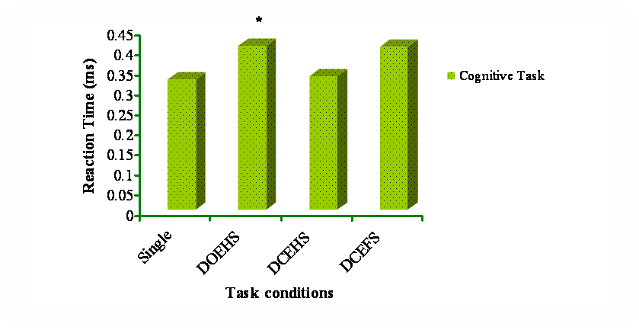
Fig 1. Comparing reaction time task under single and dual task condition

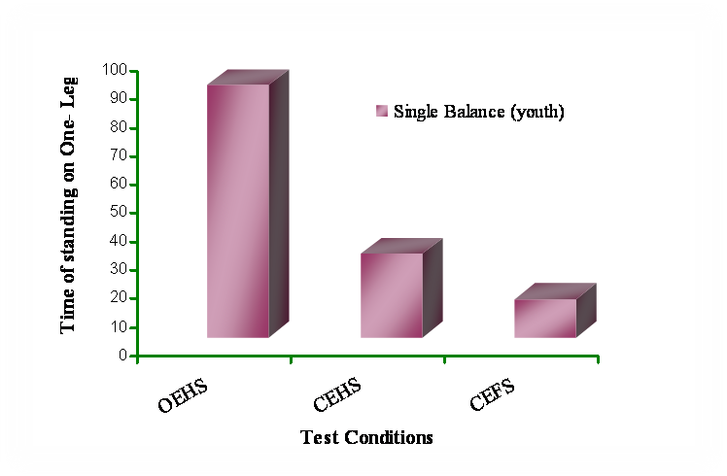
Fig 2. balance task performance under single task condition

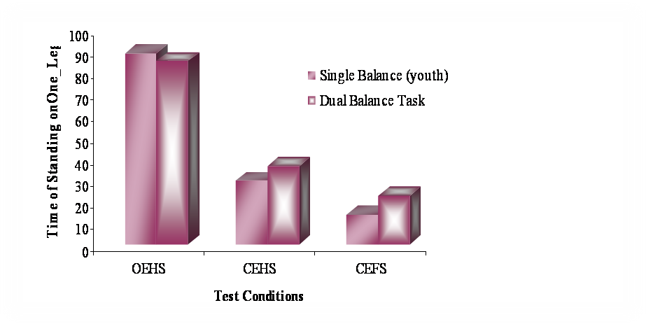
Fig 3. Comparing balance task performance under single and dual task condition

