Effectiveness of a rehabilitation method based on Existential approach and Olson's model on marital satisfaction of Mastectomy women and their husband

Maedeh Naghiyaee, Bahman Bahmani, PhD.;
University of Social Welfare and Rehabilitation Sciences, Tehran, Iran
Ali Ghanbari Motlagh,PhD
Shahid Beheshti University of Medical Sciences and Health Services
Bijhan Khorasani,PhD,
University of Social Welfare and Rehabilitation Sciences, Tehran, Iran
Aida Dehkhoda.; Fahimeh Alimohamadi
University of Social Welfare and Rehabilitation Sciences, Tehran, Iran
Mastectomy as a treatment for breast cancer can disturb marital satisfaction of many couples. In this way, existential anxiety stemming from this potentially deleterious event and inefficient responses to them, could be mediating. The purpose of this study is to investigate the effectiveness of a rehabilitation method based on existential approach and Olson's marital enrichment model on marital satisfaction of women who had undergone mastectomy and their husbands. In this study, a single subject research design (Type A-B) is used. The study population comprised couples who had referred to Radiotherapy department of Imam Hussein hospital in Tehran, that among them three couples whose average age was 20 to 50 year, wife's had undergone mastectomy, tumor has not spread to other parts of the body, and had no prior history of psychiatric disorders before cancer, were selected through purposive sampling and Intervention in 12 sessions of 90 minutes once a week, has been designed to suit their specific needs. The level of couple's marital satisfaction was evaluated using Dyadic Adjustment Scale (DAS).Comparing couple's scores on the diagram during 9 time measurement (3 times baseline, 4times during intervention, and 2times follow up assessment) and calculating recovery percent, represent increasing in score of marital adjustment scale. So it seems that, this kind of an eclectic couple therapy, by considering couples existential anxiety, has been promoted marital satisfaction of these couples.

Keywords: Marital satisfaction, marital rehabilitation, eclective method based on existential approach and Olson's model, Mastectomy

Introduction

Breast cancer is a common chronic illness among women. according to American Cancer Society reports(2011), a woman living in the US has a 12.15%, or a 1 in 8, lifetime risk of being diagnosed with breast cancer.

Due to increases in screening, early detection, and technology, women with breast cancer are living much longer; however, they continue to face many psychosocial difficulties
related to the experience of having breast cancer.

One of the prevalent treatment methods employed for breast cancer, is Mastectomy which is a technique involving cutting and disembodying the breast with tumor in a surgical operation and psychological distresses in these patient are expected.

In fact probability of losing one breast or both is the most major concern of women with breast cancer(3), Because due to serious deformation of the breast tissues, body image disturbance and severe psychological consequences, most of its effects demonstrate on marital relationships with husband ,

That's why they refer breast cancer as relational cancer .

A disease that targets the couples relationships and even after the end of treatment, marks an important transition period for patients, the time that women are faced with themselves as a cancer survivor , and may start an extended period of cure, when existential issues with unpredictability and uncertainty are highlighted.
Meanwhile, spouses as well as many changes in their lifestyle that experience have major concerns about possibility of losing wife , , uncertainty, unpredictability and lack of preparation to help wife .

Although these existential anxiety are expected consequences of facing with life threatening events in short time in a case of inability to finding and giving meaning effectively, can lead to demoralization,,,which could disturb couples relationship and their marital satisfaction,.

Therefore, couples confront with a significant task: the task of giving meaning to this potentially fatal disease with its all consequences and integrate it with all aspects of their lives.
Despite several interventions conducted for couples facing breast cancer, but lack of equal effectiveness for both patients and their partners, limited maintenance of improvements over time or, a common concern with brief psychosocial interventions, not paying attention to couple's existential anxiety and emphasis on promoting couple's relationships were their gaps.

It seems that this apparent confusion about the purpose of couple interventions is understandable given that their development and testing in the context of cancer care is a relatively new field of study (20, 21).

So this question remains that by considering breast cancer as existential-psychological stressors which can affect couple's relationships and disturb their marital satisfaction, what is the effective intervention to meet couple's needs?
It seems that preparing an intervention which simultaneously consider couples existential crisis and finding meaning and promoting their relationships, is vital.
The aim of existential therapy in relation to life threatening illnesses is that by providing supportive environment help individual to confront with existential concerns like death anxiety, uncertainty, meaninglessness, loneliness, and uncontrollability which intensify by cancer threats .
In other hand, Olson's model is based on systems theory which aims to helping couples to be aware of each other, exploring thoughts and feelings, promoting empathy and intimacy and effective relationships and problem solving .
Therefore the aim of this study is that evaluate the effectiveness of an eclectic rehabilitation method to couple therapy based on an existential approach with Olson's marital enrichment model on marital satisfaction of mastectomy women and their husband.
Method: A single case experimental design which called an A-B form, with three baselines (every 10 days) and two follow-up (every 3 weeks) was used in this study. Also the result was compared with other measurements during and end of intervention (in third, sixth, ninth and twelfth sessions).
Our statistical population was chosen from couples who had referred to radiotherapy department of Imam Hussein hospital in Tehran that among them three couples whose average age was 20 to 50 year, wife's had undergone mastectomy, tumor has not spread to other parts of the body, and had no prior history of psychiatric disorders before cancer, had lower score in DAS scale, and the women that had high score in Demoralization Scale, were selected through purposive sampling and Intervention in 12 sessions of 90 minutes once a week, has been designed to suit their specific needs.
Our data collected by Dyadic Adjustment Scale , and Demoralization scale .
DAS scale is a 32-item scale and one of the most widely used self-report measures of marital satisfaction. An alpha of 96% for the DAS was reported. Demoralization Scale is a 24-item scale and widely used self- report measures of Demoralization. An alpha of 94% for the DS was reported.

Table1. Characteristics of Couples
 | Couple A | Couple B | Couple C
Age of women  Age of husband  Duration of marriage  Education of women  Education of husband  DAS Score (W)  DAS Score(H)  DS Score(W) | 43  48  27  High school  Diploma  80  85  34 | 48  50  32  High school  Diploma  75  82  34 | 35  36  13  Diploma  Elementary  82  88  35

The protocol of an eclectic method to couple therapy based on Existential approach with Olson's model has developed within two stages of interventions that each one has three sub stage including beginning, middle and the final stage. The therapies were designed and performed with a particular focus on specific goals. The total goals of beginning sub stage of existential therapy can be summarized as: to create a safe space for the couples to procure a sense of security, to establish a therapeutic relationship for preparing the groundwork for outflowing couple's anxieties, to proliferate the feeling and ideas. The middle substage‟s goals were focused on couple's self-disclosure, being aware of here and now, existential anxieties such as death, loneliness, unpredictability and uncontrollability events, responsibility, meaninglessness, feelings of guilt and couples communication about this anxieties and distorted thoughts and beliefs which limit their perspective about unpredictable events of life. The aim of final sub stage of existential therapy was devoted to summarize the content and to evaluate the effect of intervention and preparing them to second stage. The aims of beginning stage of can
The total goals of beginning sub stage of marital enrichment intervention were getting to know the process of marital enrichment program. The middle substage‟s goals were focused on barriers to communication, promoting their conversation skills, emotional support, and intimacy. Empathy and distorted thoughts about body. The aim of final sub stage was devoted to summarize the content and to evaluate the effect of intervention. Like other single-subject designs, Chart analysis process was used to analyze the data. Also the emerged changes were considered as the effect of independent variable on the dependent variable.

Results:
Couple A
Diagram 1 show that marital satisfaction level of woman and her husband respectively are 80-81 and 85 at the baseline statement. These scores show lower level of marital satisfaction in DAS. Woman obtained a score of 90 at the end of session 3; and her husband obtained 96; this increasing continued until the end of the intervention. As in last session, woman score in follow up 2 was 130, and husband score was 135 in DAS. This result indicates increase in marital satisfaction of couple. Woman and her husband percent of recovery respectively are 62% and 58% for marital satisfaction. Also demoralization level of woman is 34 at the baseline statement. These scores show higher level of marital demoralization in DS. Woman obtained a score of 20 at the end of session 3; this reduction continued until the end of the intervention. As in last session, woman score in follow up 2 was 10 in DS. This result indicates reduction in woman demoralization. Woman percent of recovery is 70%.
(See figure1)

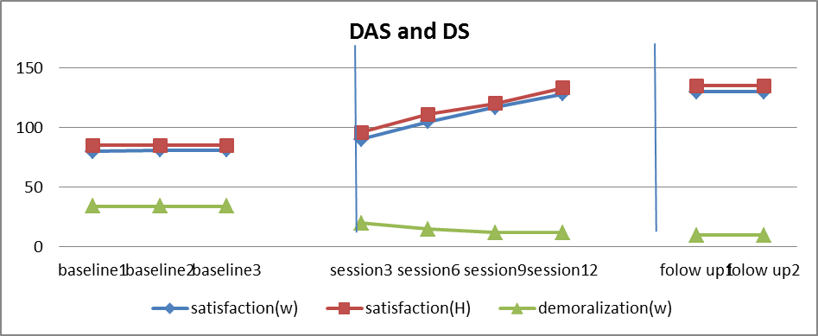figure1. Marital satisfaction and Demoralization trend of couple A

Couple B
Diagram 1 show that marital satisfaction level of woman and her husband respectively are 75 and 82 at the baseline statement. These scores show lower level of marital satisfaction in DAS. Woman obtained a score of 95 at the end of session 3; and her husband obtained 91; this increasing continued until the end of the intervention. As in last session, woman score in follow up 2 was 128, and husband score was 120 in DAS. This result indicates increase in marital satisfaction of couple. Woman and her husband percent of recovery respectively are 70% and 46% for marital satisfaction. Also demoralization level of woman is 33 at the baseline statement. These scores show higher level of marital demoralization in DS. Woman obtained a score of 24 at the end of session 3; this reduction continued until the end of the intervention. As in last session, woman score in follow up 2 was 13 in DS. This result indicates reduction in woman demoralization. Woman percent of recovery is 60%.
(See figure2)

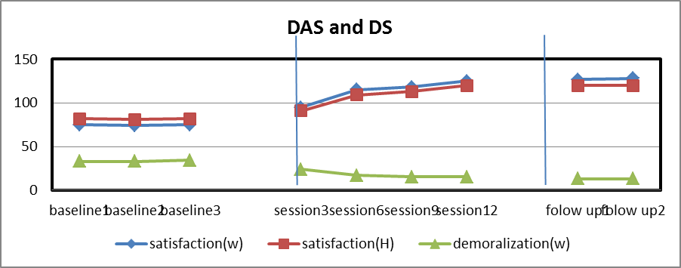 figure2. Marital satisfaction and Demoralization trend of couple B

Couple C
Diagram 1 show that marital satisfaction level of woman and her husband respectively are 82 and 88 at the baseline statement. These scores show lower level of marital satisfaction in DAS. Woman obtained a score of 95 at the end of session 3; and her husband obtained 91; during other sessions we don’t see significant increasing until the end of intervention. As in last session, woman score in follow up 2 was 97, and husband score was 99 in DAS. This result indicates not increasing in marital satisfaction of couple. Woman and her husband percent of recovery respectively are 18% and 11% for marital satisfaction. Also demoralization level of woman is 35 at the baseline statement. These scores show higher level of marital demoralization in DS. Woman obtained a score of 25 at the end of session 3; this reduction continued until the end of the intervention. As in last session, woman score in follow up 2 was 17 in DS. This result indicates reduction in woman demoralization. Woman percent of recovery is 51%.
(See figure3)

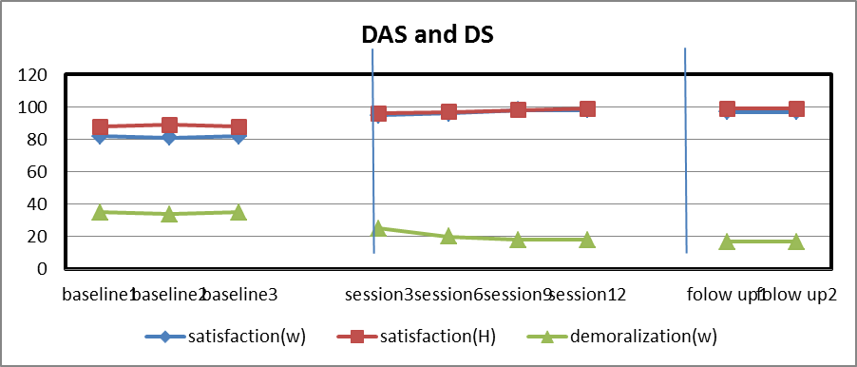 figure3. Marital satisfaction and Demoralization trend of couple c

The trend of changes in couples‟ marital satisfaction scores within 9 times of completing questioner will be presented in the following table:

Table 2. Couples marital satisfaction scores
Marital satisfaction | Baseline1 | Baseline2 | Baseline3 | Session3 | Session6 | Session9 | Session12 | Follow1 | Follow2
woman A | 80 | 81 | 81 | 90 | 105 | 117 | 128 | 130 | 130
husband A | 85 | 85 | 85 | 96 | 111 | 120 | 133 | 135 | 135
woman B | 75 | 74 | 75 | 95 | 115 | 118 | 125 | 127 | 128
husband B | 82 | 81 | 82 | 91 | 109 | 113 | 120 | 120 | 120
woman C | 82 | 81 | 82 | 95 | 96 | 98 | 98 | 97 | 97
husband C | 88 | 89 | 88 | 96 | 97 | 98 | 99 | 99 | 99

The trend of changes in women's‟ demoralization scores within 9 times of completing questioner will be presented in the following table:

Table 3. Women demoralization scores
Demoralization | Baseline1 | Baseline2 | Baseline3 | Session3 | Session6 | Session9 | Session12 | Follow1 | Follow2
woman A | 34 | 34 | 34 | 20 | 15 | 12 | 12 | 10 | 10
woman B | 33 | 33 | 34 | 24 | 17 | 15 | 15 | 13 | 13
woman C | 35 | 34 | 35 | 25 | 20 | 18 | 18 | 17 | 17

The table 2 depicted increasing in marital satisfaction scores for couples A and B in Dyadic adjustment Scale from lower satisfaction to the higher one. So we can say that our hypothesis which is based on the effectiveness of an eclectic couple therapy based on existential approach with Olson's model on mastectomy women and their husband has been proved.
Discussion:
Increasing trend of marital satisfaction scores can be perceived as the effectiveness of eclectic couple therapy based on existential approach and Olson's model on mastectomy women and their husband.

These hypotheses can be proven true with the following discussion: couples experience an existential crisis following breast cancer. The crisis involves violations of basic assumptions about their sense of control and ability to predict the future.
Such major stressors challenge or shatter individuals’ world- and self-views because there is a discrepancy between the information inherent in

the stressor, on the one hand, and couple’s positively skewed expectations and beliefs about the world, on the other hand. For example, the belief that ‘bad things do not happen to good people’ is seriously challenged when a ‘good person’ gets a cancer diagnosis.

In these couples, denial of existential anxiety led them to feel sadness and guilt and fear of recurrence. At the same time, couple's inability to communicate about this fears with each other, led them to feel existential loneliness more and more that laid out a deep gap in their relationships.

Moreover, demoralized women, because of felling incompetency and inability to give meaning to these events, started to making meaning such as paying off, God punishment, and God revenge.

Goes without saying that these meaning could disturb couples marital satisfaction. In fact not only present situation was not adapting to an expected situation, but also, inefficient meaning barricaded them to communicate and cope effectively.

Existential therapy helped couples confront with their own existential anxiety and accept them as unavoidable anxieties of existence and communicate about them. This process helped couples to know that they are not alone in such existential experience and started to find and give an effective meaning to this event.
In fact, discussing spiritual and religious matters with one’s spouse in the context of a supportive environment will contribute to a shared spiritual meaning of the relationship, greater connection and understanding of one another, and a stronger investment in the marriage, which are likely related to enhanced marital quality .
So this process of awareness and conjoint meaning, significantly helped couples to increase their marital satisfaction and find each other as an important Source of support.
Acknowledgements:
We gratefully acknowledge the very helpful participation of the participants, Dr. Bahman Bahmani and Dr. Ali Ghanbari Motlagh for providing guidance and support.

1. Society AC. Breast cancer facts & figures 2011-2012.
2. Pukay-Martin M.D. Couple connection and cancer: Understanding the mechanisms of partner support for women with breat cancer: University of North Carolina.; 2009.
3. Cohen M.Z, Kahn D.L, Steeves RH. Beyond body image: The experience of breast cancer. Oncol Nurs Forum. 1998;25:835-41.
4. Compas B.E, L. L. Psychological adjustment to breast cancer. Current directions in psychological science. American Psychological Society. 2001;11(3):111-4.
5. Avci I.A, H K. Marital Adjustment and Loneliness Status of Women With Mastectomy and Husbands Reactions. Asian Pacific J Cancer Prev. 2011;12:453-9.
6. Northouse L.L, Templin T, Mood D, M O. Coples adjustment to breast cancer and benign breast disease :A longitudinal analysis. Psycho-Oncology. 1998;7:37-48.
7. Marcus A.C, Garrett K.m, Cella D, Wenzel L.B, Brady M.J, L.A C. Telephon counseling of breast cancer patients after treatment:A description of a randomized clinical trial. Psycho-oncology. 1998;7:470-82.
8. Mullane M, Dooley B.E, U B. Validation of the Demoralization Scale in an Irish advanced cancer sample. Palliative and Supportive Care. 2009;7:323-30.
9. Bahmani B, Etemadi A, Shafiabadi A, Delavar A, A GM. Cognitive-Existential group therapy and Cognitive Instructional therapy for breast cancer patients. Developmental Psychology: Iranian Psychologist. 2010;6(23):201-14.
10. Fekete E.M, Stephens M.A.P, Mickelson K.D, J.A D. The role of perceived emotional responsiveness. Families,Systems&Heaalth. 2007;2:204-17.
11. Baider L, Walch N, Perry Sh, A.K D-N. cancer in married couples:higher or lower distress. Journal of psychosomatic research. 1998;3:239-48.
12. Carlson L.E, Bultz B.D, Pierre M, M S. Patners ofcancer patients: Part II,Current psychosocial interventions and suggestions for improvememnt. Journal of Psycho Oncology. 2000;3:33-43.
13. K K. Enhancing dyadic coping during a time of crisis: A theory-based intervention with breast cancer patients and their partners: In T. A. Revenson, K; 2005.
14. H K. Religion, Spirituality, and Medicine: Research Findings and Implications for Clinical Practice. Southern Medical Journal. 2004;12:1194-200.
15. Kissane D.W, Clark D.M, A.F S. Demoralization syndrome. A relevant psychiatric diagnosis for palliative
care. Journal of Palliate care 2001;17:12-21.
16. Vehling S, Lehmann C, Oechsle K, Bokemeyer C, Krull A, Koch U, et al. Global meaning and meaning-related life attitudes: exploring their role in predicting depression, anxiety,and demoralization in cancer patients. Support Care Cancer. 2011;19:513-20.
17. Vehling S, Lehmann C, Oechsle K, Bokemeyer C, Krull A, Koch U, et al. Is advanced cancer associated with demoralization and lower global meaning? The role of tumor stage and physical problems in explaining existential distress in cancer patients. Psycho-Oncology
2012;21:54-63.
18. V.E F. Psychotherapy and existentialism: New York: Washington Square Press; 1967.
19. Kalantarkousheh F.M , A HS. Function of life meaning and marital communication among Iranian spouses in Universiti Putra Malaysia. Procedia Social and Behavioral Sciences. 2010;5:1646-9.
20. Baik O.M, K.B A. Improving the well-being of couples facing cancer : A review of couples-based psychosocial interventions. Journal of Marital and Family Therapy. 2011;2:250-66.
21. Hopkinson J.C, Okamoto L, J.M A-H. The effectiveness of patient-family carer (couple) intervention for the management of symptoms and other health –related problems in people affected by cancer: A systematic literature search and narrative review. Journal of pain and symptom management. 2011;7(1-32).
22. G C. Theory and practice of counseling and psychotherapy, translated by Seyed Mohamadi, Y. Tehran: Arasbaran Publication; 2005.
23. Bowling T, C.M H. An overview of marriage enrichment. The family Journal. 2005;13:87-94.
24. G S. Measuring Dyadic Adjustment : New scale for assessing the quality of marriage and similar dyads. . Journal of marriage and family. 1976;1:15-28.
25. Kissane D, Wein S, Love A, Qing Lee X. The Demoralization Scale: a Report of Its Development and Preliminary Validation. Journal of Palliative Care. 2004;20:269-76.
26. G.K K. Couples dyadic spirituality and marital communication and love: The utility of moving from general to in depth indication of shared spirituality between spouses [A Thesis, of the requirements for the degree of master of art..
.]2010.

. This study derived from Master thesis in family counseling
. All correspondences to Dr. Bahman Bahmani, E-mail: bbahmani43@yahoo.com

